

K. K. WAGH POLYTECHNIC

HirabaiHaridasVidyanagari,Amrutdham, Panchavati,Nashik – 422003

**Department of Computer Technology**

**(Academic year 2015-16)**

SYNOPSIS

* **TITLE of PROJECT:**

**External Drive Protection System**

* **PROJECT GROUP PARTNERS:**

|  |  |  |  |  |
| --- | --- | --- | --- | --- |
| **Sr.**  **No.** | **Name of Student** | **Class &**  **Roll No.** | **E-mail ID** | **Mobile No.** |
| 1. | Akshay S. Chavan | 25 | akshay97chavan007@gmail.com | 98822479700 |
| 2. | Prasad V. Kadam | 62 | prasadkadam560@gmail.com | 9130405031 |
| 3. | Pankaj S. Hambre | 47 | pankajhambre@gmail.com | 9403451231 |
| 4. | Akshay S. Jamdhade | 57 | akshay117aj@gmail.com | 8087640278 |

* **INTERNAL GUIDE:** Prof G. B. Katkade
* **SPONSOR DETAILS:**

|  |  |
| --- | --- |
| Company/Industry/Organization Details | Contact Persons Details at Sponsor |
| Name: Spryan Inc. , Nashik | Name: Mr. P. S. Kulkarni |
| Address: C2, Venus Arcade, Near Narayan Baapu Nagar Chowk, Jail Road, Nashik Road, Nashik-03 | Designation: C.E.O.  Department: - |
| Office Phone Nos.: (0253)411344 | Mobile No: 9145800554/ 8484091729 |
| email ID: spryan@gmail.com | email ID: pankajkulkarni1985@gmail.com |
| Website: http://www.spryan.org |  |

**Place: Nashik**

**Project Title:**

**External Drive Protection System**

**Abstract**

Viruses and other malicious programs are an ever increasing threat to current external drive and computer system. They can cause damage and consume countless hours and system administration time to combat.People use external drives for all kind of storing activities: music, video, softwares, documents, etc. At the same time, the risk of infection by malicious programs in these external drives is rising many viruses could enter into external drive.These malicious program may corrupt or alter the data on the external drive and also the computer systems where the external drive is connected. The main issue is that general users don't understand what a virus is and how external drives get infected. General users don't understand that how a virus may corrupt the data. A virus-infected drive can then infect any other computer where you might use the drive. Once plug a virus-infected drive in any system, the system will be filled with many viruses

The purpose of this software utility project is to protect external drives from malicious program on their own. The external drive will contain it’s own antivirus which will defend the external drive from various malicious program ensuring the security of it’s own. This software utility will help general users to protect their data from various malicious programs. Also many viruses enters computer system through internet or external devices connected, this utility will reduce the risk of malicious programs which enters computer system through external devices

**Keywords:**

Portable Antivirus, External drive security, Virus blocker,USB Antivirus, Protect External Drives, Virus detection system, antivirus software.

**Introduction:**

Any external drive can be infected by malicious programs. This malicious programs may enter your external drive. Once your external drive has been infected, all the data on it might get corrupted or deleted. Also it will infect every computer system where it is connected.This can be avoided by keeping an antivirus program on external drive itself which will protect it from various viruses

**Project Concept and Working:**

Portable Antivirus is a small virus removal utility.It not only can detect and remove viruses but it can also find worms,Trojans,ad-worms,mal-wares which doesn't required system installed Protection(Antivirus). When external drive is connected, the antivirus utility will start automatically and protect the drive from various viruses. This utility will scan every executable file which enters the external drive and compare it with the definitions available in database

**Area of Project**:

This project falls under protection of external devices from various kinds of thefts and making them more secured. This utility will scan each file and check it for whether it is infected or not. Using this utility users can be secured on their own. It will protect the data of users from various theft

**Features:**

* **Easy-to-use**

Interface makes scanning your computer for viruses a snap

* **Custom Scan**

Lets you specify which folders to scan

* **Quick Scan**

Reduces software scan times to a few minutes

* **Smart Feedback**

Shares threat information to quickly discover new threats

* **Review and Restore**

Lets you check and compare scan results and recover files

* **Enhanced Detection and Cleanup**

Addresses rootkits and other sophisticated threats

* **Enhanced Scanning**

Enhanced performance speeds threat detection

* **Plug n Play**

Antivirus will automatically start when device is connected

**Design Concept:**

VB DOTNET is used as the front end as it is the latest and flexible technology which is comprised of C and Visual C++. It has a wide range of features which are very useful. This utility will compare the executable files with the database in virus definitions and determine that file is infected or not. When external drive is connected, the antivirus utility will start automatically and protect the drive from various viruses. This utility will scan every executable file which enters the external drive and compare it with the definitions available in database

**Block Diagram:**

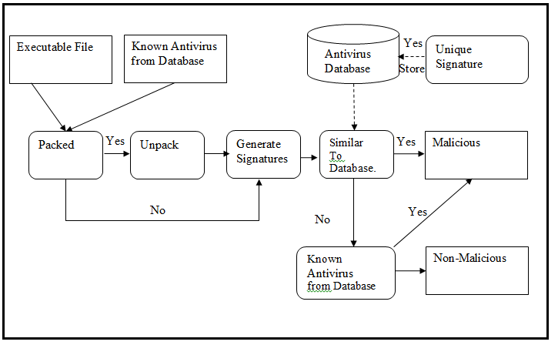

***Fig. 1.0 Working of Antivirus System***

**Hardware Requirements for Development of Project:**

**Processor**

* For Windows 10/8/7/Vista: 1 GHz
* For Windows XP: 300 MHz

**RAM**

* 50mb or above

**Hard disk space**

* 25 MB of available external disk space

**Software Requirements for Development of Project:**

* Microsoft Windows XP (Service Pack 1)or any above Version.
* .Net framework 3.0 or above

**Advantages of this Project:**

* **Virus Vault**

Infected files are moved to vault

* **Disable Protection**

Antivirus system can be disabled for some time duration

* **Virus Exception**

Exception of a virus can be addedthis will exclude the file and not scan the it

* **Scanning of Individual Files**

You may find you need to run a program or open a file but are unsure if it is safe. Using this utility you can scan a single file also to check whether it is safe to access it or not.

* **Data remains secured**

The data remains secured also when the system is infected with viruses

**Limitations/Constraints of Project:**

* **Update offline**

The virus database should be updated without internet connection

* **Limited Detection Techniques**

There's more than one way to detect a virus, but one big disadvantage to some antivirus programs is that they may not employ all detection techniques

* **File is completely deleted**

When a file is detected as virus, it is removed directly. The file is not repaired

* **May create conflict**

This utility may create a conflict with the antivirus available in the computer system

**Conclusion:**

This project has dropped a small stone in water, by designing an application that provides a generic antivirus approach that is used to scan the files efficiently. “External drive protection sytem” being developed by restricting to the present technology available in our college meets the desired needs of the requirements completely.

Our system can be extended further to an extent at which it can provide more facilities and flexibility than it provides at present. At present the disassembling of the file to be scanned is limited to the exe files that were written in C and C++ only. The disassembler provided in this system may not work properly when we are going to scan the files that are written in other high level languages. So more the decompiling tools we can add we can scan a wide range of variety of files.

**Future Scope:**

At present in our system only the files that were scanned and reported as affected can be deleted or can be moved to vault to delete in future. So the only option provided for the user is to delete the affected file. More over the affected file can be repaired by deleting the virus code that was matched from the disassembled code and restoring the new file from the repaired code

**References:**

1. Peter Zsor, The art of computer virus research and defense, Addison-Wesley, Maryland, USA, 2005.
2. Michael Erbschloe., Trojams, Worms, and Spyware, Butterworth-Heinemann publications. Oxford, UK, 2005
3. John Aycock, Computer Virus and Malware, Springer Science+Business Media, LLC. Calgary,Canada, 2006.
4. Cameron H. Malin, Eoghan Casey, James M. Aquilina, Malware Forensics: Investigating and Analyzing Malicious Code, Spi Publishing Services, Burlington, USA, 2008.
5. Mark A Ludwig, The Giant Black Book of Computer Viruses, American Eagle Publication, Arizona, USA, 1995.
6. William Stallings, Cryptography and Network Security: Principles and Practice, Prentice Hall, Inc., New Jersey, USA, 1999.

**Web Reference:**

http://www.anti-virus-softwarereview.com

http://www.antivirus-software.com

http://www.buzzle.com/articles/ different-types-of-computerviruses.html

http://www.spamlaws.com/%20virus-types.html

http://www.ehow.com/list-7258284- computer-virus-detectiontechniques.html